Zombie Shooter

# game mechanics

Top down shooter, the aim of the game to for the player to explore the level and defeat all the enemies.



There will be obstacles such as lava and walls and enemies will come in singular or groups.

When all the enemies are defeated the boss will spawn, once the boss is dead onto the next level.

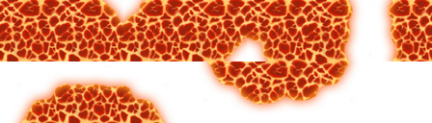

We are hopeful to have a level each as we are a 3 man team and we are using GitHub and Trello to exchange ideas / update code.

Player Functions

* Player will have health and when the player collides with enemies or lava, the health will diminish and player will die. Player will have 3 lives and once the lives have fallen below 0 the game will be over. The player will have Ammunition, and a reload time.

L:\Assessment 3\grenade.png Player will also have the ability to throw a grenade to damage multiple enemies, with a separate ammunition count and cooldown timer, so the player can’t simply spam it.

**If we have time we will try to upgrade the player reload time, ammunition, movement speed etc with a currency or score. Ammo will be found around the level, or maybe a drop chance from enemies.**

Enemy Functions

Enemy will simply patrol back and forth or around a square formation and will agro towards the player after they have been hit or the player gets too close to the enemy.

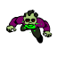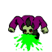

The enemy will have attacking animation that will do damage to player health.

Can also attack from a distance with spit projectile.

**Upon death, the enemy will add to the players score and possibly drop ammo or a coin.**

Keys / Buttons

WASD or Arrow Keys to move the player.

Button1 to shoot bullets.

Button 2 to throw grenade.

Target Audience

Top down shooters, older school retro gamers, indie gamers.

Rough Flow Chart

|  |
| --- |
|  |

Rough Schedule

